Context-Stable Explanations and Conformal Deferral for Credit Decisions with Tabular Foundation Models
Niveditha Venkatesh
School of Electronics and Computer Science and Engineering
Vellore Institute of Technology, Chennai
Register No: 24BLC1039
Abstract— Tabular foundation models are a new kind of machine-learning model. They are trained once on millions of artificial tables and can then make predictions on a new dataset straight away, without any training. This changes how a bank can explain and control its credit decisions. Tree SHAP no longer applies, the model's own uncertainty can decide when a human should check a decision, and because the model learns from a "context set" of past applicants, an applicant's rejection reasons may change when that set changes. We rebuild our earlier three-tier credit evaluation system around TabICLv2 and TabPFN and add a new explanation-stability gate. On the corrected South German Credit data, TabPFN gave a higher ROC-AUC than the Random Forest of our earlier work on all ten splits (0.804 vs 0.790, Wilcoxon p = 0.002) and lowered expected misclassification cost by about 6% (p = 0.041). Conformal deferral met its promised coverage but made the same errors as a fixed window at the same workload, and applicants under 25 were deferred about twice as often as older applicants. Shapley explanations reached 0.9 top-3 agreement with 128 (TabICLv2) to 256 (TabPFN) model runs, costing 38 s to 4 min for one applicant on a T4 GPU. When the context set was resampled, two explanations of the same applicant shared only about two of three top reasons (mean Jaccard 0.49–0.52 at 600 rows, against a noise ceiling of 0.89), and the most important reason changed for 51–62% of applicants. This instability was similar for a retrained Random Forest, so it is largely a property of small-data credit models. Under a milder, realistic update (each context keeping 90% of its rows) agreement rose to 0.76–0.78, but the main reason still changed for 38–41% of applicants with the foundation models, against 24% for the Random Forest. In the full system, applicants flagged by the new stability gate were wrongly decided 53% of the time against 38–41% for the rest, and combining the uncertainty and stability gates gave the lowest cost on automatic decisions for both models.
Index Terms— Credit Scoring, Tabular Foundation Models, TabPFN, TabICL, Explainable AI (XAI), Shapley Values, Conformal Prediction, Human-in-the-Loop Deferral, Algorithmic Fairness.

I. Introduction

A. Background and Motivation
Banks and FinTech companies now use machine-learning models to decide who gets a loan. These models are often accurate, but it is hard to see why they make a decision. Regulators ask lenders to be transparent, to avoid discrimination and to keep a human in control of important automated decisions. A credit system therefore has to be accurate and explainable and safe to automate.
In our earlier work (Paper 1), we built a three-tier system around a Random Forest. It used Tree SHAP explanations as live control signals: a "circuit breaker" stopped a decision and sent it to a human when the predicted risk was close to 50% or when one feature had too much influence. That paper showed the idea works, but it used a standard model and a hand-picked threshold, so it did not add much that was new.
Since then, tabular foundation models have appeared. TabPFN [1] and TabICLv2 [2] are transformers trained on millions of synthetic tables. Given a small table of past applicants (the context set), they predict for a new applicant in one forward pass, with no training or tuning. On small datasets like German Credit (1,000 rows), they often beat tuned tree models. A recent study already compared these models with classical methods on credit data [3], so "the foundation model is more accurate" is no longer new on its own. What has not been studied is what these models change for explanation and deferral to a human, and that is the focus of this paper.

B. Problem Statement
When a credit system is built on a foundation model, three practical questions appear that earlier work does not answer:
- Deferral. The model gives probabilities with well-behaved uncertainty. Can this uncertainty, combined with conformal prediction, decide when to ask a human, instead of the fixed 0.46–0.54 window used in Paper 1?
- Speed of explanation. Tree SHAP does not work for these models. Shapley values must be estimated by re-running the model many times. How much accuracy of the explanation is lost if we make it fast enough for real-time use?
- Stability of explanation. The model's answer depends on the context set. If the bank adds or removes past applicants, do an applicant's rejection reasons stay the same? If not, which reasons should the applicant be told?

C. Research Questions
- RQ1 (accuracy): On small credit data, do foundation models beat tuned tree ensembles on ranking quality, calibration and cost?
- RQ2 (deferral): Does conformal deferral give a better risk–coverage trade-off than a fixed probability window, and is deferral spread evenly across groups?
- RQ3 (real-time explanation): How much Shapley accuracy is lost when the computation budget is cut to meet a per-applicant time limit?
- RQ4 (stability, headline): When the context set changes, how much do an applicant's top-3 rejection reasons change?

D. Contributions
- A three-tier credit system rebuilt on TabICLv2 and TabPFN, with three deferral gates: uncertainty (conformal), attribution (protected features) and a new explanation-stability gate.
- A fair benchmark against five tuned or reference baselines over 10 paired splits, with significance tests (RQ1).
- A study of conformal deferral and of who gets deferred, by age and foreign-worker status (RQ2).
- A measured speed–accuracy curve for Shapley explanations of foundation models (RQ3), and the first study of how stable credit rejection reasons are when the context set changes, with worked examples of individual applicants (RQ4).
This paper extends Paper 1 [4] with a new model family and new research questions; no figures or results are reused from it.

E. Report Organization
Section II reviews related work by theme; Section III compares prior studies; Section IV states the research gap; Section V describes the system; Section VI gives the experimental setup; Section VII presents the results for RQ1–RQ4 and the full system; Section VIII discusses what they mean for lenders and regulators; Section IX lists the limitations; Section X lists future work; Section XI concludes. Appendix A contains the original Colab outputs and Appendix B the verification checks.

II. Literature Survey
Related work falls into four themes.

A. Theme A: Tabular Foundation Models
TabPFN [1] is a transformer trained on millions of synthetic datasets. It approximates Bayesian prediction and works in one forward pass. Its Nature paper reports that it beats earlier methods on datasets of up to 10,000 rows. TabICLv2 [2] follows the same in-context learning idea, scales to larger tables and has an open, permissive licence, which is why we use it as a main model. A 2026 benchmark [3] found that these models give the best average results for credit default prediction, with the largest gains on small, imbalanced data. These studies measure accuracy only; they do not study explanation or deferral.

B. Theme B: Explaining Foundation Models
Shapley values [5] give each feature a fair share of a prediction. For tree models, Tree SHAP [6] computes them exactly and quickly. Foundation models are not trees, so Rundel et al. [7] proposed remove-and-recontextualise: to see the effect of leaving out some features, the model is simply given a context set without those columns. Because the model does not need retraining, this is cheap per evaluation, but many evaluations are needed. The speed–accuracy cost of this for real-time credit decisions has not been measured.

C. Theme C: SHAP in Credit Scoring
SHAP is widely used to explain credit models, for example to show how checking balance, savings or debt affect risk [8]. In most studies the explanation is a report produced after the decision. Paper 1 [4] turned SHAP into a live control signal for a Random Forest. Slack et al. [9] showed that explanations can be unstable or even manipulated, which is why the stability of an explanation matters before it is shown to an applicant.

D. Theme D: Conformal Prediction and Deferral to Humans
Conformal prediction [10], [11] turns any model's scores into prediction sets with a guaranteed coverage, for example "the true label is in the set 90% of the time". When the set contains both "good" and "bad", the case is uncertain and can be sent to a human. Group-wise (Mondrian) conformal gives the guarantee separately for each group. Regulations such as Article 14 of the EU AI Act (human oversight) and the RBI FREE-AI report ask for this kind of human control, but these methods have not been combined with foundation models in credit.

III. Comparative Analysis of Related Work
Table I compares the main prior work on three questions that matter for this paper.
TABLE I. Comparison of related work
Ref. | Work | Main idea | Found. model | Uncertainty-based deferral | Explanation stability tested
[1] | Hollmann et al. (2025) | TabPFN, in-context prediction | Yes | No | No
[2] | Qu et al. (2026) | TabICLv2, scalable in-context model | Yes | No | No
[3] | Credit FM benchmark (2026) | Foundation models for credit risk | Yes | No | No
[7] | Rundel et al. (2024) | Shapley values for TabPFN | Yes | No | No
[6] | Lundberg et al. (2020) | Fast exact Tree SHAP | No | No | No
[8] | Zhang et al. (2023) | SHAP for consumer credit | No | No | No
[10] | Angelopoulos & Bates (2021) | Conformal prediction guide | No | Yes (general) | No
[4] | Paper 1 (2026) | RF + SHAP circuit breaker | No | Fixed window | No
— | This work | Foundation-model gating with 3 gates | Yes | Yes (conformal) | Yes

IV. Formulation of the Research Gap
Research Gap Statement: Prior work on tabular foundation models for credit measures only accuracy. No study uses the model's own uncertainty, through conformal prediction, to decide when a human should review a credit decision; none measures how fast Shapley explanations of these models can be produced for one applicant; and none tests whether an applicant's rejection reasons stay the same when the model's context set changes. As a result, it is not known whether foundation-model explanations are reliable enough to be shown to applicants or used as control signals.

V. System Architecture and Methodology
The system keeps the three-tier structure of Paper 1 but replaces the model and the gating rules (Fig. 1).
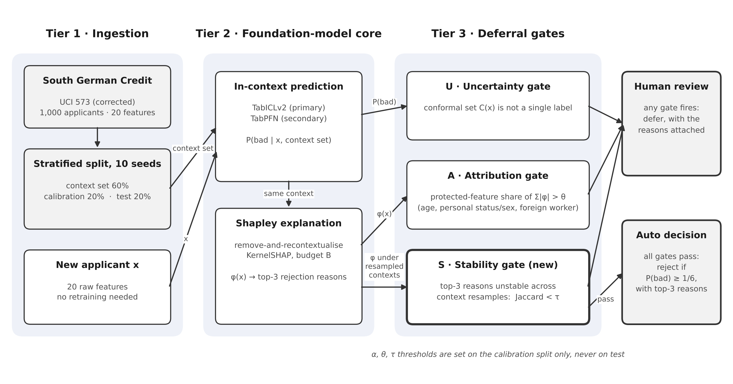
Fig. 1. Proposed three-tier framework: Tier 1 (Ingestion), Tier 2 (Foundation-model core), Tier 3 (Deferral gates).

A. Tier 1: Data Ingestion
We use the corrected South German Credit data (UCI ID 573) [12] instead of the older Statlog version, because the Statlog coding of sex and foreign-worker status is wrong. It has 1,000 applicants, 20 features and a 70:30 good-to-bad ratio. For each of 10 random seeds, the data is split, keeping the 70:30 ratio, into a context set (60%, 600 applicants), a calibration set (20%, 200) and a test set (20%, 200). The split row numbers are saved to files so that every model uses exactly the same splits. Foundation models take the 20 raw features directly, so the clipping and Z-score scaling of Paper 1 are not needed.
Three attributes are treated as protected: age, personal status/sex and foreign-worker status. In the corrected data, sex cannot be fully recovered, because the code for "male single" is the same as for "female non-single". We therefore use personal status/sex only as a protected feature in the attribution gate, and we study fairness of deferral by age band (under 25 vs 25 and over) and foreign-worker status.

B. Tier 2: Foundation-Model Core
The core is TabICLv2 [2] or TabPFN (version 3.5) [1], each used with its default settings and no tuning. The model receives the context set and the applicant, and returns the probability that the applicant will default, P(bad). Decisions use the cost-optimal rule for the dataset's 5:1 cost matrix (approving a bad applicant costs 5, rejecting a good applicant costs 1): reject if P(bad) ≥ 1/6.
Explanations use remove-and-recontextualise Shapley values [7]: the value of a group of features is the model's prediction when only those feature columns are kept in the context set. The values are estimated with KernelSHAP [5] using paired sampling, and the number of model evaluations per applicant is called the budget B. The three largest positive values give the applicant's top-3 rejection reasons.

C. Tier 3: Deferral Gates
A decision is sent to a human if any of three gates fires.
- U – Uncertainty gate (conformal). On the calibration set we compute a score s = 1 − p̂(true label) for each applicant and take the ⌈(n+1)(1−α)⌉/n quantile q̂. For a new applicant, the prediction set is C(x) = {y : p̂(y|x) ≥ 1 − q̂}. If C(x) contains both labels, or is empty, the case is deferred. This replaces the fixed 0.46–0.54 window of Paper 1.
- A – Attribution gate. Defer if the protected features together account for more than a share θ of the total |φ|. θ is set on the calibration set (90th percentile).
- S – Stability gate (new). Re-explain the applicant with 5 resampled context sets. Defer if the top-3 reasons agree poorly (mean Jaccard similarity below τ, set at the 10th percentile on the calibration set).
All thresholds (α, θ, τ) are chosen on calibration data only, never on test data.

VI. Experimental Setup
Baselines. Logistic regression scorecard; Random Forest with the Paper 1 settings (200 trees, balanced class weights); and Random Forest, XGBoost, LightGBM and CatBoost tuned with Optuna [13] (50 trials, 3-fold cross-validation on the context set only).
Metrics. ROC-AUC (how well the model ranks risky applicants above safe ones), PR-AUC, Brier score and expected calibration error (ECE, how closely predicted probabilities match real default rates), expected cost per applicant under the 5:1 cost matrix, and fit + predict time.
Repetition and testing. E1–E3 run over 10 seeds (0–9) and report mean ± standard deviation. Because each foundation-model run costs 0.3–1 s on the GPU, the explanation experiments use fewer splits: E4 one split (so far) and E5 three splits. Because all models use the same splits, models are compared seed by seed with the Wilcoxon signed-rank test [14].
Hardware and software. Google Colab with an NVIDIA T4 GPU and 2 CPU cores; Python 3.12; tabicl (checkpoint tabicl-classifier-v2-20260212), tabpfn (TabPFN-3.5 weights, non-commercial licence), scikit-learn, XGBoost, LightGBM, CatBoost and Optuna. Every number comes from a script and a saved result file.

VII. Experimental Results and Discussion

A. RQ1: Accuracy of Foundation Models vs Tree Models (E1)
Answer: TabPFN was the best model, by a small but consistent margin; TabICLv2 was not clearly better than Random Forest. Table II shows the results over 10 splits, and Fig. 2 shows them visually.
TABLE II. Test-set results over 10 splits (mean ± SD)
Model | ROC-AUC ↑ | PR-AUC ↑ | Brier ↓ | ECE ↓ | Exp. cost ↓ | Time (s)
TabPFN | 0.804 ± 0.035 | 0.674 ± 0.057 | 0.156 ± 0.012 | 0.063 ± 0.022 | 0.528 ± 0.047 | 4.06*
TabICLv2 | 0.793 ± 0.034 | 0.651 ± 0.056 | 0.161 ± 0.013 | 0.058 ± 0.025 | 0.550 ± 0.040 | 1.90
RF (Paper 1) | 0.790 ± 0.033 | 0.638 ± 0.057 | 0.163 ± 0.009 | 0.067 ± 0.019 | 0.559 ± 0.050 | 0.58
RF (tuned) | 0.783 ± 0.037 | 0.632 ± 0.070 | 0.165 ± 0.011 | 0.065 ± 0.019 | 0.574 ± 0.056 | 1.05
LightGBM | 0.782 ± 0.032 | 0.644 ± 0.053 | 0.163 ± 0.013 | 0.067 ± 0.025 | 0.583 ± 0.058 | 0.19
XGBoost | 0.779 ± 0.033 | 0.634 ± 0.047 | 0.164 ± 0.012 | 0.063 ± 0.015 | 0.578 ± 0.032 | 0.11
Logistic | 0.778 ± 0.028 | 0.624 ± 0.058 | 0.167 ± 0.013 | 0.070 ± 0.020 | 0.571 ± 0.035 | 0.04
CatBoost | 0.774 ± 0.033 | 0.618 ± 0.059 | 0.167 ± 0.012 | 0.064 ± 0.017 | 0.565 ± 0.042 | 1.90
* TabPFN time includes the first-time model loading on seed 0; the median should be reported in the final version. ↑ higher is better, ↓ lower is better.
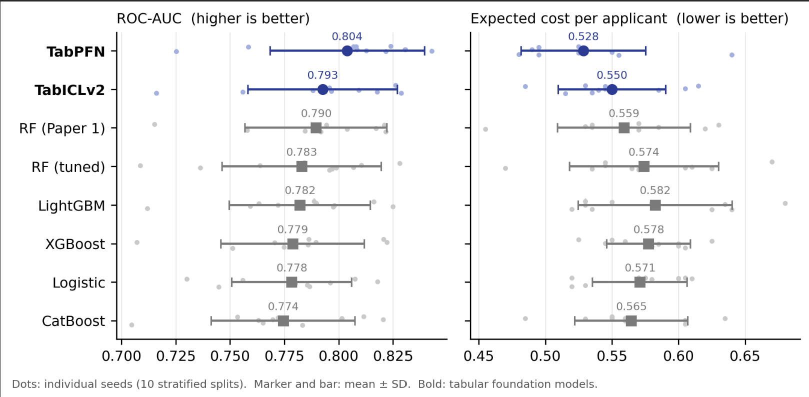
Fig. 2. ROC-AUC and expected cost per model. Dots: individual splits; marker and bar: mean ± SD. Foundation models in blue.
Because the standard deviation (about ±0.035) is larger than the difference between models, we compared the models split by split (Table III, Fig. 3). On the same split, TabPFN beat the Paper 1 Random Forest on all 10 splits for ROC-AUC (+0.014, p = 0.002) and had lower expected cost on 8 of 10 (−0.031, p = 0.041). TabPFN also beat the tuned Random Forest and LightGBM. TabICLv2 was significantly better only than LightGBM.
TABLE III. Paired comparison over 10 splits (Wilcoxon signed-rank test)
Comparison | Δ ROC-AUC | Splits better | p | Δ Exp. cost | Splits better | p
TabPFN − RF (Paper 1) | +0.0143 | 10/10 | 0.002 | −0.0305 | 8/10 | 0.041
TabPFN − RF (tuned) | +0.0208 | 10/10 | 0.002 | −0.0455 | 9/10 | 0.006
TabPFN − LightGBM | +0.0217 | 9/10 | 0.004 | −0.0540 | 9/10 | 0.004
TabICLv2 − RF (Paper 1) | +0.0031 | 8/10 | 0.160 | −0.0090 | 6/10 | 0.453
TabICLv2 − RF (tuned) | +0.0097 | 7/10 | 0.105 | −0.0240 | 8/10 | 0.131
TabICLv2 − LightGBM | +0.0105 | 7/10 | 0.037 | −0.0325 | 7/10 | 0.039
For cost, "splits better" counts the splits where the foundation model had the lower cost; ties are not counted as wins.
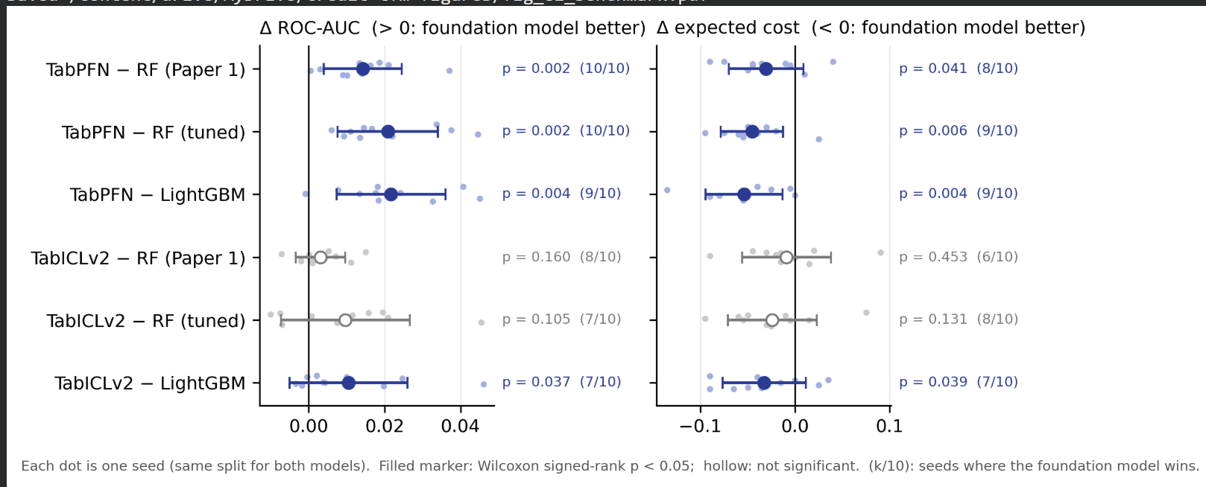
Fig. 3. Paired difference between each foundation model and each baseline on the same split. Filled markers are significant (Wilcoxon p < 0.05).
Three further observations:
- Tuning did not help the trees. The tuned Random Forest (0.783) was no better than the untuned Paper 1 forest (0.790). With only 600 training rows, there is too little data for tuning to pay off. This makes the comparison fair: the trees were given every chance.
- Calibration was similar for all models (ECE 0.058–0.070), so we do not claim a calibration advantage.
- Error rate is not the main metric. Logistic regression had the lowest error (0.373) but a higher cost, because the 1/6 cut-off is chosen to minimise cost, not error. We therefore report expected cost as the main decision metric.

B. RQ2: Conformal Deferral vs the Fixed Window (E2)
Answer: conformal deferral kept its coverage promise for every model, but at the same deferral rate it made about the same number of errors as the fixed window.
Coverage means the share of applicants whose true outcome is inside the prediction set. For every model, coverage stayed within two points of the target: about 0.95 for α = 0.05, 0.90 for α = 0.10 and 0.81 for α = 0.20 (Table IV). This confirms the conformal guarantee on real credit data.
TABLE IV. Deferral results (mean over 10 splits)
Model | Rule | Coverage | Deferred | Error on automatic decisions
TabPFN | Conformal α = 0.05 | 0.956 | 56.5% | 0.099
TabPFN | Conformal α = 0.10 | 0.908 | 34.4% | 0.138
TabPFN | Conformal α = 0.20 | 0.808 | 6.9% | 0.205
TabPFN | Fixed window 0.46–0.54 | — | 6.3% | 0.206
TabICLv2 | Conformal α = 0.10 | 0.903 | 35.4% | 0.149
TabICLv2 | Fixed window | — | 6.2% | 0.215
RF (Paper 1) | Conformal α = 0.10 | 0.901 | 35.4% | 0.152
RF (Paper 1) | Fixed window | — | 9.3% | 0.208

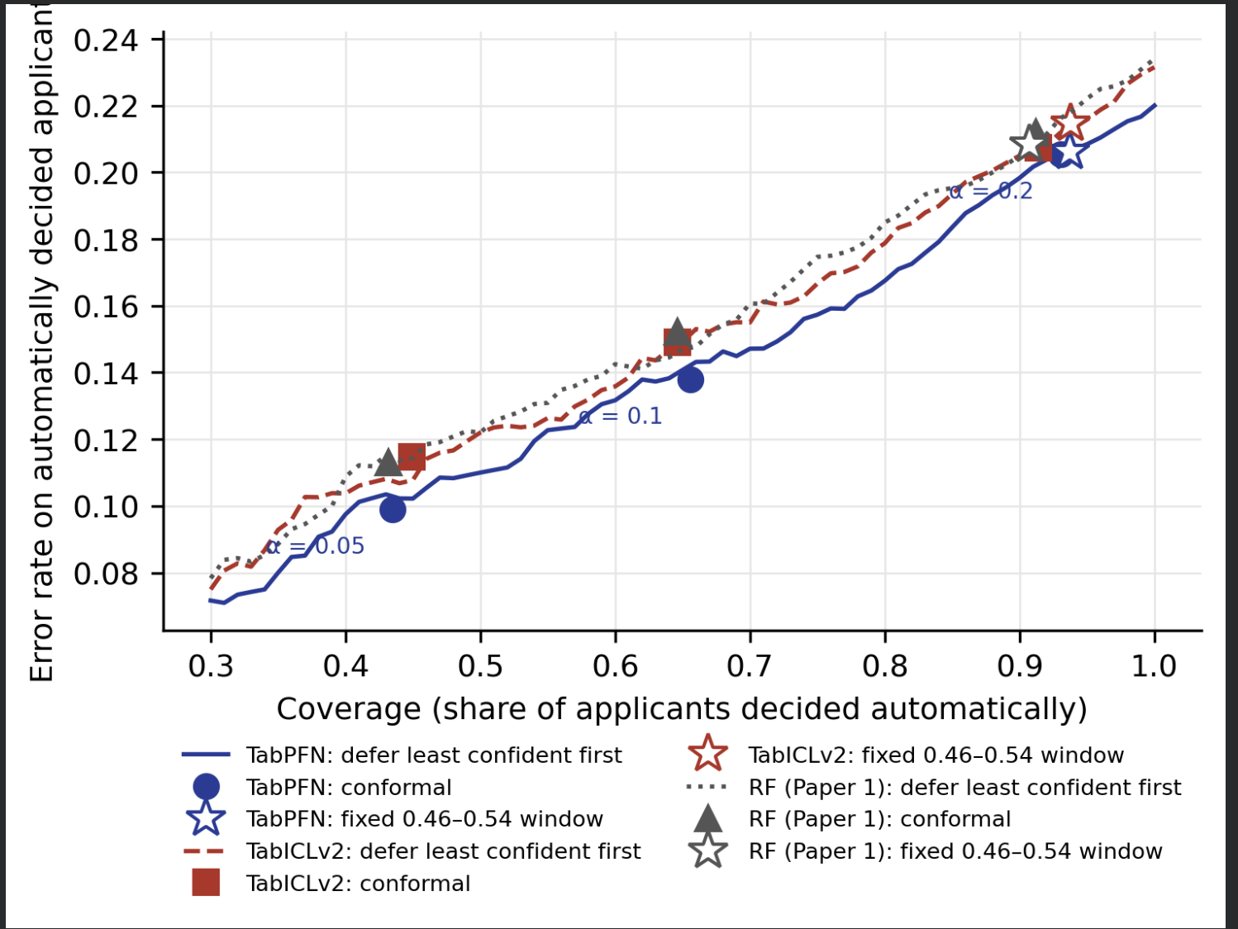
Fig. 4. Risk–coverage curves. Lines: defer the least confident applicants first. Conformal points and the fixed window (stars) lie on the same curves.
The highlighted rows in Table IV show the key point. For TabPFN, conformal deferral at α = 0.20 sent 6.9% of applicants to a human with an error of 0.205; the fixed window sent 6.3% with an error of 0.206. The two rules are practically the same at the same deferral rate, and this held for every model (Fig. 4). The benefit of conformal deferral is therefore not fewer errors but a guarantee and a clear control setting: the bank can choose α to trade human workload against error, and the promised coverage holds. The cost of that guarantee is high: at 90% coverage, about one in three applicants is deferred, which shows how uncertain credit decisions are with only 1,000 past cases.
Neither the window nor the conformal sets take the 5:1 cost matrix into account, so the expected cost on automatic decisions was higher than with the cost-optimal rule of Section VII-A. A cost-aware conformal score is left for future work; the full system (E6) uses the 1/6 cut-off for its final decisions.

C. RQ2: Who Is Deferred? (E3)
Answer: deferral was not spread evenly. Applicants under 25 were deferred about twice as often as older applicants, under every model and every rule.
TABLE V. Deferral rate by age band (pooled over 10 test sets; 1,705 aged 25+, 295 under 25)
Model | Rule | 25 and over | Under 25 | Gap [95% CI]
TabPFN | Conformal α = 0.10 | 30.0% | 60.3% | 0.30 [0.25, 0.37]
TabPFN | Group-wise conformal | 30.7% | 59.7% | 0.29 [0.23, 0.35]
TabPFN | Fixed window | 5.1% | 13.2% | 0.08 [0.04, 0.12]
TabICLv2 | Conformal α = 0.10 | 31.6% | 57.3% | 0.26 [0.19, 0.32]
RF (Paper 1) | Conformal α = 0.10 | 31.1% | 60.0% | 0.29 [0.23, 0.34]
RF (Paper 1) | Fixed window | 8.2% | 15.6% | 0.07 [0.03, 0.12]

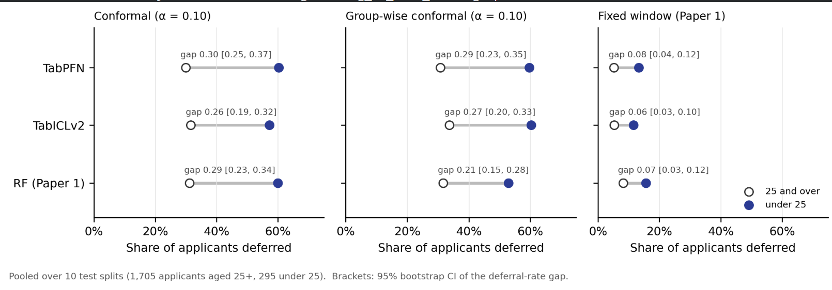
Fig. 5. Share of applicants deferred, by age band. Open circles: 25 and over; filled: under 25. Brackets: 95% CI of the gap.
No confidence interval comes close to zero, so the difference is real and not due to chance. The fixed window shows the same pattern (13.2% vs 5.1%, about 2.6 times); its gap only looks smaller because it defers fewer people overall. Group-wise (Mondrian) conformal did not close the gap, because it makes coverage equal between groups, not the deferral rate. Even after deferral, young applicants who were decided automatically faced a slightly higher error (0.171 vs 0.137 for TabPFN). Differences in the true-positive rate (equal opportunity) between age groups were also positive, but their intervals were wide (lower bounds 0.004–0.045), so this evidence is weaker.
For foreign workers, the group is very small: 37 people in the whole dataset and 65 across all ten test sets. Plain conformal deferred foreign workers less often (20% vs 35%), because most of them were good-risk applicants. Group-wise conformal made things worse (58.5% deferred), because with about seven calibration cases per split the group threshold becomes very wide. We conclude that group-wise calibration is counter-productive for very small groups, and we do not draw fairness conclusions for this group.
Whether being deferred helps or harms an applicant depends on the lender: a human review may protect the applicant, or it may delay the loan. Either way, the share of reviews falling on young applicants is something a lender should monitor.

D. RQ3: Explanation Speed vs Accuracy (E4)
Answer: about 128 (TabICLv2) to 256 (TabPFN) model runs give an explanation whose top-3 reasons match a careful reference at least 90% of the time, but that takes 38 s to 4 min for a single applicant, so exact-quality explanations are suited to batch review rather than instant decisions.
For 100 fixed test applicants, Shapley values were first computed with a large reference budget of 2,048 model runs. They were then recomputed with budgets of 32 to 1,024 runs, drawn independently of the reference. We measured agreement with the reference (Spearman correlation of all 20 values, and Jaccard overlap of the top-3 reasons) and the time to explain one applicant on its own on an NVIDIA T4 GPU. Results are for split 0 (Table VI, Fig. 6).
TABLE VI. Explanation accuracy and cost by budget (split 0, T4 GPU)
Budget B | TabICLv2 top-3 agreement | TabICLv2 time, one applicant | TabPFN top-3 agreement | TabPFN time, one applicant
32 | 0.402 | 9 s | 0.475 | 29 s
64 | 0.804 | 19 s | 0.789 | 58 s
128 | 0.902 | 38 s | 0.890 | 117 s
256 | 0.920 | 77 s | 0.960 | 236 s
512 | 0.942 | 155 s | 0.965 | 475 s
1,024 | 0.960 | 312 s | 0.975 | 949 s

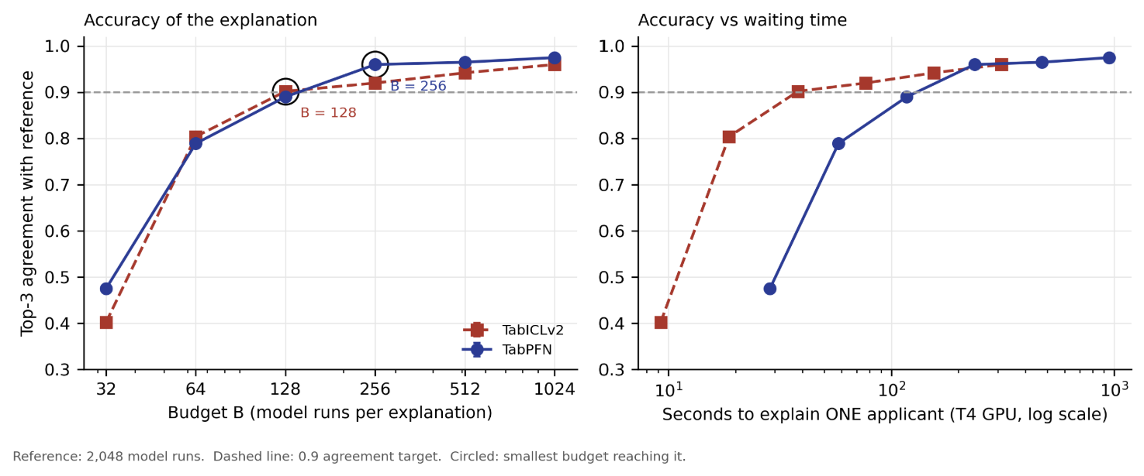
Fig. 6. Left: top-3 agreement with the 2,048-run reference against budget; circles mark the smallest budget reaching 0.9. Right: the same against the time to explain one applicant (log scale).
With only 32 runs, fewer than half of the top-3 reasons matched the reference, so very cheap explanations are unreliable. The 0.9 target was reached at B = 128 for TabICLv2 (Spearman 0.960) and B = 256 for TabPFN (Spearman 0.980). One TabICLv2 run took about 0.30 s and one TabPFN run about 0.95 s, so TabICLv2 reached the target about six times faster overall. When 100 applicants were explained together, the cost fell to 0.45 s (TabICLv2) and 2.4 s (TabPFN) per applicant, because every model run serves all applicants at once. For comparison, exact Tree SHAP for a Random Forest takes milliseconds. The "real-time" claim of Paper 1 therefore does not carry over to foundation models: their explanations are practical for overnight or batch review, not for an instant answer at the counter. These results come from one split; two more splits will add error bars.

E. RQ4: Explanation Stability under Context Change (E5, headline)
Answer: an applicant's rejection reasons change substantially when the context set changes. At 600 rows, two explanations of the same applicant share only about two of their three top reasons, and the most important reason changes for about half of the applicants. This is true for foundation models and for a retrained Random Forest alike. Under a milder, realistic update the reasons are more stable, but the main reason still changes for about 40% of applicants with the foundation models.
For the same 100 test applicants, prediction and explanation (B = 256) were repeated with 5 bootstrap resamples of the context set, at context sizes of 200, 400 and 600 rows, over 3 splits. The same sampled feature groups were reused across resamples, so any change in the reasons comes from the context set and not from random sampling. As a baseline, a Random Forest with Tree SHAP was retrained on exactly the same resamples. To separate real instability from calculation noise, each foundation model was also explained twice on the unchanged context with different random samples (the noise ceiling).
Stability was measured with the Jaccard similarity of two top-3 sets, J(A, B) = |A ∩ B| / |A ∪ B|, averaged over all pairs of resamples. For three reasons, J = 1 means the same reasons, J = 0.5 means two of three are shared, and J = 0.2 means one is shared.
TABLE VII. Stability of explanations under context resampling (mean of 3 splits)
Model | Context rows | Top-3 Jaccard | Kendall τ | Top-1 changes | Decision flips
TabPFN | 200 | 0.340 | 0.278 | 69.7% | 37.3%
TabPFN | 400 | 0.430 | 0.359 | 64.3% | 26.3%
TabPFN | 600 | 0.515 | 0.441 | 51.0% | 22.7%
TabPFN | noise ceiling | 0.892 | 0.786 | — | —
TabICLv2 | 200 | 0.331 | 0.277 | 77.7% | 39.3%
TabICLv2 | 400 | 0.417 | 0.352 | 69.3% | 31.0%
TabICLv2 | 600 | 0.486 | 0.419 | 61.7% | 24.3%
TabICLv2 | noise ceiling | 0.886 | 0.783 | — | —
RF + Tree SHAP | 200 | 0.377 | 0.429 | 72.7% | 39.7%
RF + Tree SHAP | 400 | 0.449 | 0.485 | 66.0% | 33.0%
RF + Tree SHAP | 600 | 0.479 | 0.499 | 56.3% | 33.0%
Top-1 changes: share of applicants whose most important reason is not the same in all 5 resamples. Decision flips: share whose approve/reject decision (P(bad) ≥ 1/6) is not the same in all 5 resamples.
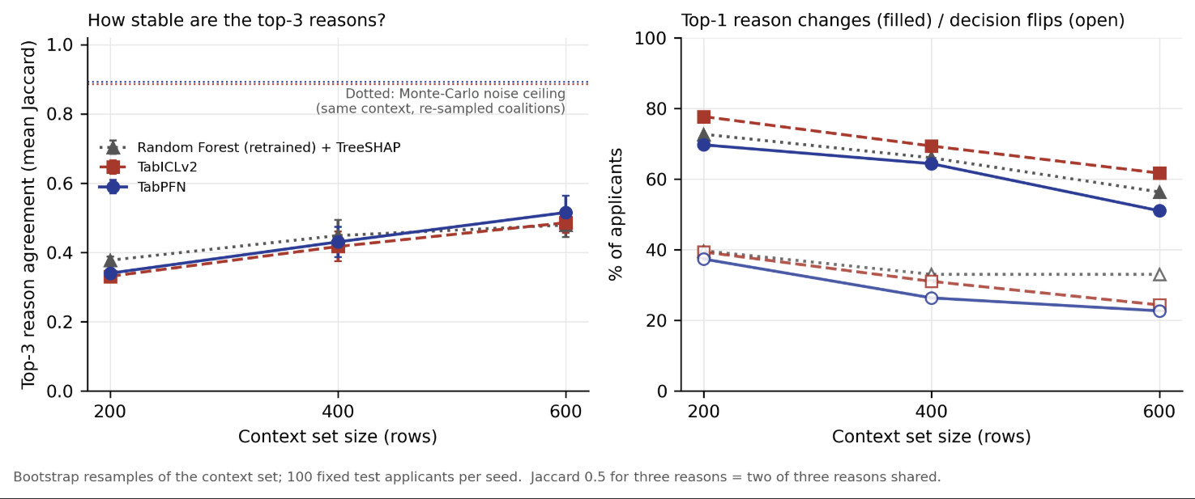
Fig. 7. Left: top-3 reason agreement against context size; dotted lines: noise ceiling. Right: share of applicants whose top-1 reason changes (filled) and whose decision flips (open). Error bars: SD over 3 splits.
Four points stand out. First, the instability is real: agreement at 600 rows (0.49–0.52) is far below the noise ceiling (0.89), so it is caused by which past applicants are in the context set, not by the explanation method. Second, more data helps but does not solve it: agreement rises steadily from 200 to 600 rows for every model and has not levelled off. Third, under a full bootstrap, foundation models are not worse than retraining a Random Forest: they start slightly less stable at 200 rows but catch up at 600 rows, where TabPFN is the most stable model (0.515). The Random Forest keeps a higher Kendall τ, meaning its lower-ranked features are more consistent, while the foundation models agree better on the top reasons. Fourth, decisions themselves change: about a quarter of applicants are approved under one resample and rejected under another with the foundation models, against a third with the Random Forest. These are mostly applicants close to the 1/6 cut-off.
TABLE VIII. Worked examples (TabICLv2, split 0, 600-row context, 5 resamples)
Resample | Applicant 562 (truly bad): P(bad) and top-3 reasons | Applicant 738 (truly good): P(bad) and top-3 reasons
1 | 0.84: installment rate, duration, job | 0.44: purpose, installment rate, status
2 | 0.77: personal status/sex, purpose, installment rate | 0.33: purpose, status, credit history
3 | 0.75: purpose, duration, savings | 0.21: amount, property, telephone
4 | 0.71: purpose, status, age | 0.37: status, savings, installment rate
5 | 0.79: purpose, age, status | 0.27: status, property, installment rate

Table VIII shows what this means for a real applicant. Applicant 562 is correctly rejected every time, but a protected attribute (personal status/sex or age) appears among the top-3 reasons in three resamples and not in the other two, so an attribution-based fairness check would flag this applicant or not purely by chance. Applicant 738 is a good applicant who is wrongly rejected in every resample, and would be told that the main reason was the loan purpose, the account status or the loan amount depending only on which past applicants the model saw (mean pairwise Jaccard 0.24 and 0.26). An applicant who receives such a reason cannot rely on it to improve their chances. This is the motivation for the stability gate S: an explanation should be checked across several context resamples before it is shown to an applicant or used as a control signal.
A milder, more realistic change. Bootstrap resampling is a strong change: each resample keeps only about 63% of the distinct original rows. We therefore repeated the test with a milder update, in which each context set keeps a random 90% of the 600 rows (540 rows, as if a bank replaced 10% of its past applicants); two such contexts share about 81% of their rows. This was run on split 0 with the same 100 applicants, 5 resamples and budget B = 256 (Table VIIa).
TABLE VIIa. Stability under a milder update (each context keeps 90% of rows; split 0)
Model | Top-3 Jaccard | Kendall τ | Top-1 changes | Decision flips
TabPFN | 0.777 | 0.694 | 38% | 10%
TabICLv2 | 0.755 | 0.745 | 41% | 11%
RF + Tree SHAP | 0.760 | 0.741 | 24% | 5%
(full bootstrap, 600 rows, 3 splits, for comparison) | 0.48–0.52 | 0.42–0.50 | 51–62% | 23–33%
(noise ceiling) | 0.89 | 0.78–0.79 | — | —

With a realistic update the reasons are much more stable: top-3 agreement rises to 0.76–0.78, about halfway between the full bootstrap and the noise ceiling, and decisions flip for only 5–11% of applicants. The instability does not disappear, however. Even when 90% of the past applicants stay the same, the most important reason changes for 38–41% of applicants with the foundation models, against 24% with the retrained Random Forest, and their decisions flip about twice as often (10–11% against 5%). So under small, realistic updates the foundation models are somewhat less stable than a Random Forest at the level that matters most to an applicant, the main reason. This is one split only and should be confirmed on more splits, but it strengthens the case for the stability gate: a bank that simply adds new applicants to the context set will change the main reason given to many of its customers.

F. The Full System: Which Gates Help? (E6)
Answer: the best setting is the uncertainty gate plus the new stability gate (U + S), chosen on calibration data for both models. The stability gate catches decisions that are wrong more often (53% vs 38–41%), while the attribution gate does not catch errors at all.
The full system was run on 100 test applicants per split over 3 splits, with every combination of the three gates: U (conformal set not a single label, α = 0.10), A (protected features carry more than the 90th-percentile share of the explanation) and S (top-3 reasons unstable across 5 context resamples, below the 10th percentile). All thresholds were set on 100 calibration applicants. Decisions on applicants that pass all gates use the cost-optimal rule (reject if P(bad) ≥ 1/6).
TABLE IX. Gate ablation on test applicants (mean of 3 splits)
Gates on | TabICLv2: deferred | cost of auto | age gap | TabPFN: deferred | cost of auto | age gap
none | 0% | 0.573 | 0.000 | 0% | 0.570 | 0.000
U | 32.3% | 0.557 | 0.157 | 32.3% | 0.553 | 0.131
A | 9.7% | 0.587 | 0.257 | 12.7% | 0.590 | 0.309
S | 11.0% | 0.565 | 0.140 | 13.7% | 0.547 | 0.108
U + A | 38.3% | 0.584 | 0.274 | 39.3% | 0.573 | 0.271
U + S (recommended) | 38.0% | 0.546 | 0.193 | 40.3% | 0.514 | 0.105
A + S | 18.7% | 0.587 | 0.236 | 23.7% | 0.574 | 0.206
U + A + S | 43.0% | 0.576 | 0.288 | 46.0% | 0.531 | 0.192
Cost of auto = expected cost per automatically decided applicant (5:1 cost matrix). Age gap = deferral rate of under-25s minus 25+. The recommended setting minimises total cost on calibration data, counting each human review as 0.5.
TABLE X. Does each gate flag the risky decisions? (error rate of the automatic rule)
Gate | TabICLv2: flagged | not flagged | TabPFN: flagged | not flagged
U (uncertainty) | 0.600 | 0.301 | 0.602 | 0.331
S (stability, new) | 0.533 | 0.384 | 0.526 | 0.408
A (attribution) | 0.348 | 0.395 | 0.438 | 0.421

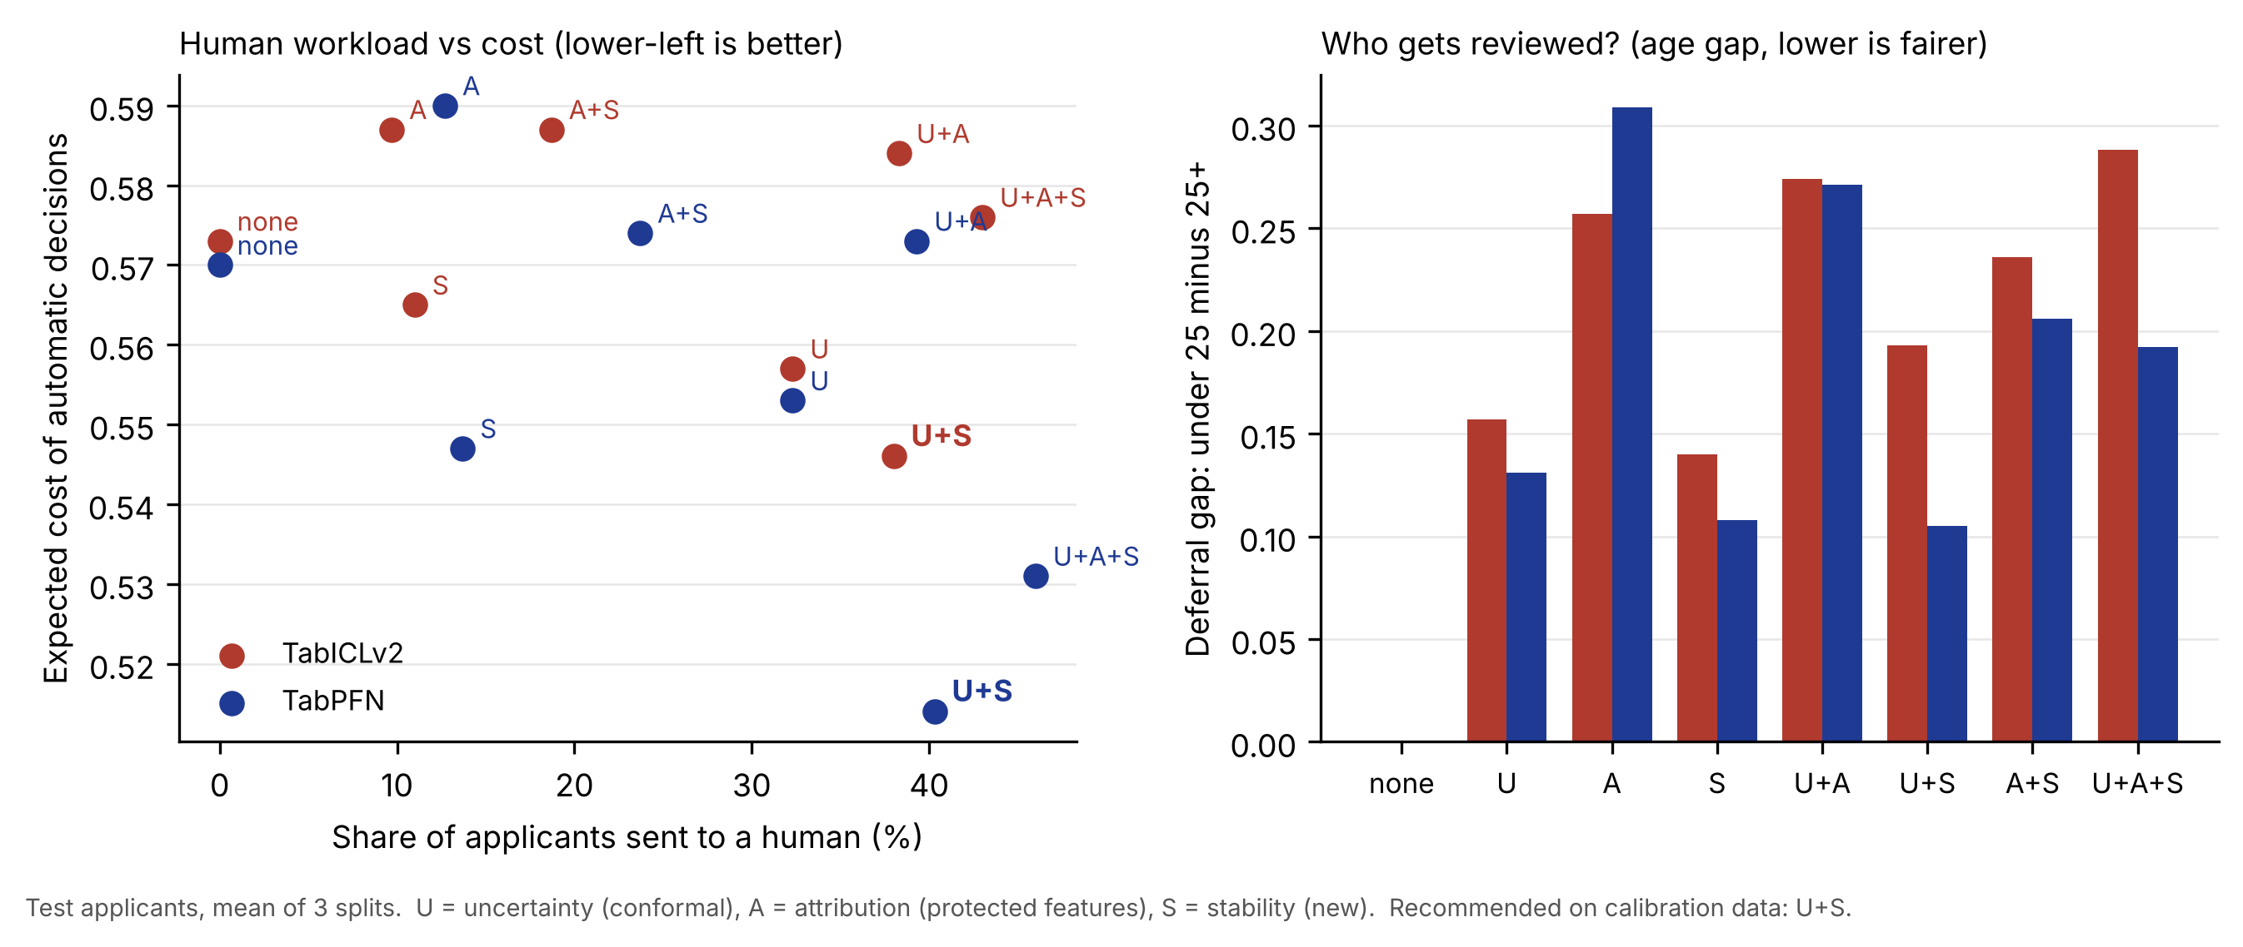
Fig. 8. Left: share of applicants sent to a human against the expected cost of automatic decisions for every gate setting (lower-left is better). Right: age gap in deferral for each setting.
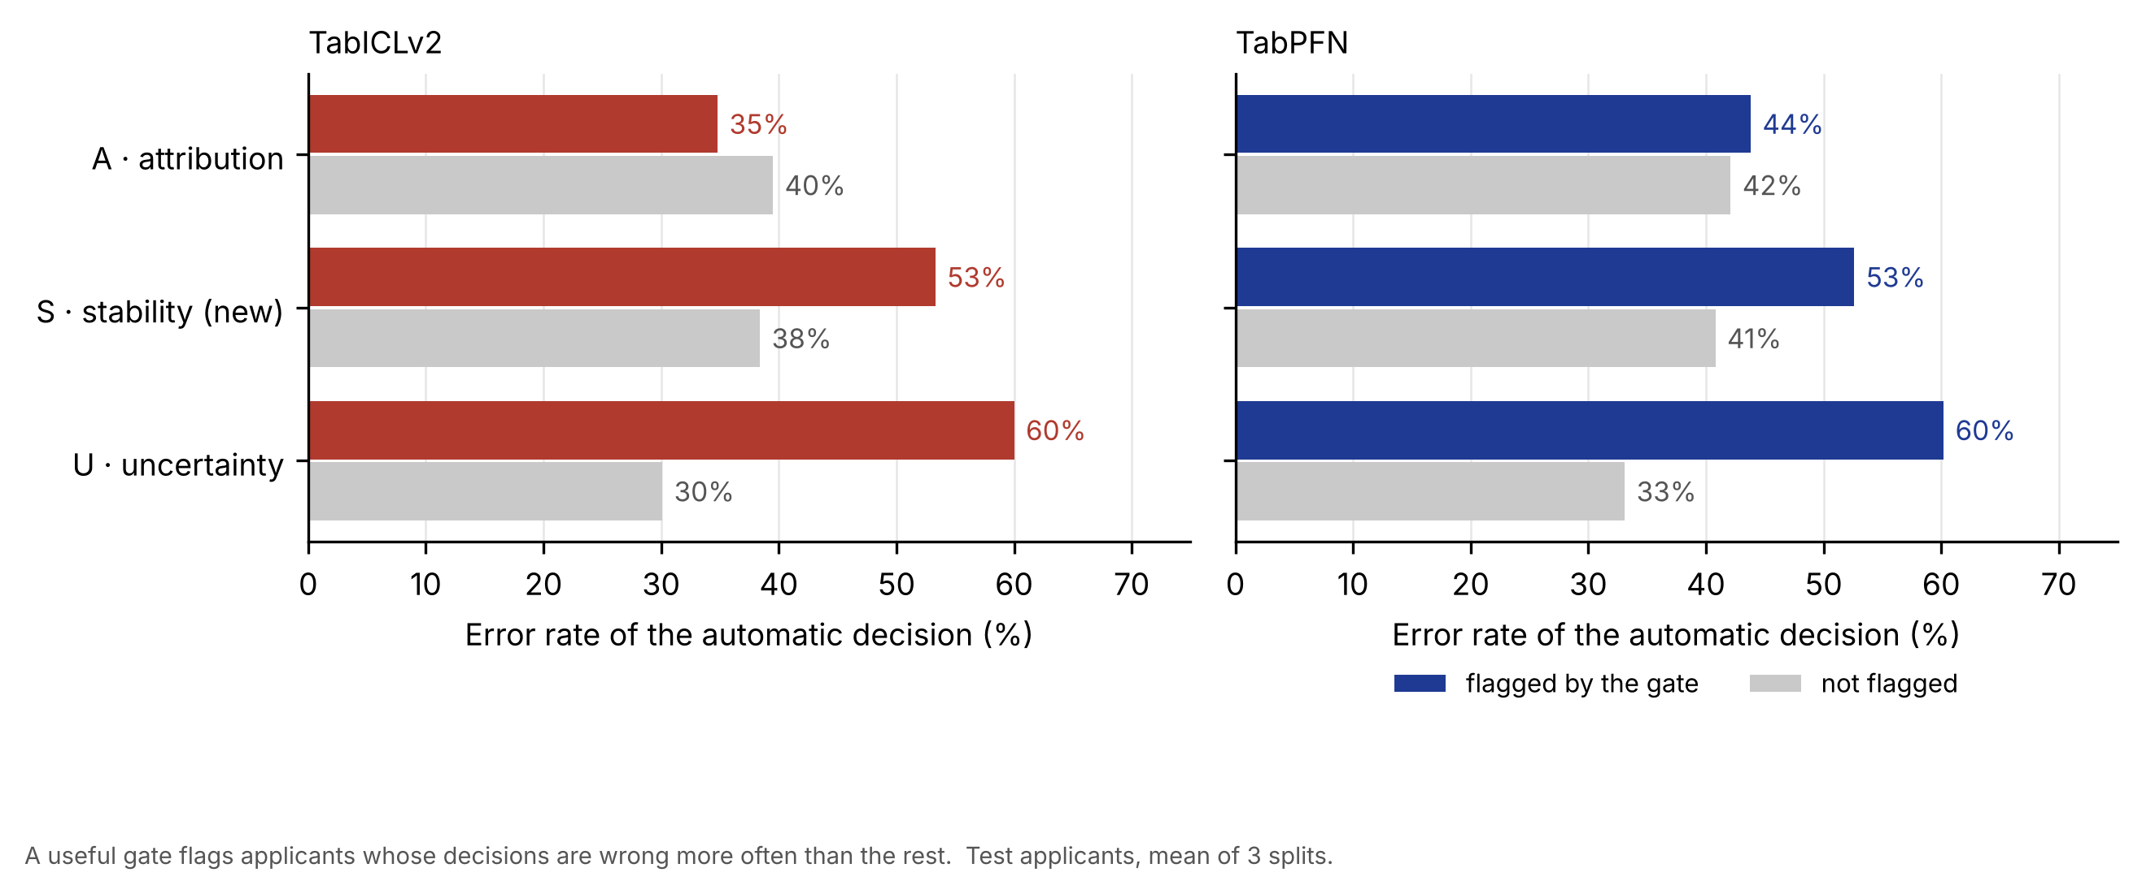
Fig. 9. Error rate of the automatic decision for applicants each gate flags (coloured) and does not flag (grey). U and S flag clearly riskier decisions; A does not.
Three conclusions follow. First, the stability gate is useful: applicants with unstable reasons were wrongly decided 53% of the time, against 38–41% for the others, so instability is a warning sign and not only a reporting problem. It also has the smallest age gap of any single gate (0.11–0.14). Second, the attribution gate does not catch errors: flagged and unflagged applicants have about the same error, and adding A makes both cost and the age gap worse, because age itself is one of the protected features. A should therefore be treated as a compliance rule, not as a risk filter. Third, U + S gives the lowest cost on automatic decisions (0.514 for TabPFN, against 0.570 with no gates and 0.553 with U alone), and for TabPFN it also has a smaller age gap than U alone (0.105 vs 0.131). The price is human workload: about 40% of applicants are reviewed. The choice of U + S depends on the assumed review cost of 0.5 per case; a bank with more expensive reviews would choose fewer gates. The error rates themselves (about 0.30–0.42) are high because the 1/6 cut-off deliberately rejects many good applicants to avoid approving bad ones.

VIII. Discussion

A. What the Results Mean for Lenders
Use the foundation model for scoring, but do not treat its explanation as a fixed fact. TabPFN ranked applicants better than tuned tree models and lowered expected cost on all splits, without any tuning. That makes it attractive for small lenders with few past loans. The same small data, however, makes the explanations fragile: about half of the applicants would be told a different main reason if the bank's set of past applicants changed. Under a full bootstrap a retrained Random Forest behaves the same way, so the problem is mostly a property of learning from 600 past cases. Under a small, realistic update the foundation models change their main reason more often than the Random Forest (38–41% against 24%), so for them the stability check matters even more.
Check stability before giving reasons. Our results suggest a simple rule: before a rejection reason is sent to an applicant, explain the decision again with a few resampled context sets and send the reason only if it is stable. When it is not, the case should go to a human. E6 shows that this is not only a reporting safeguard: applicants whose reasons were unstable were wrongly decided 53% of the time, against 38–41% for the others.
Plan for batch explanation. A reliable explanation costs 38 s (TabICLv2) to about 4 minutes (TabPFN) for one applicant on a T4 GPU, but under 2.5 s per applicant in batches of 100. A practical design is to give the decision immediately and send the explanation later, for example with the decision letter. If speed matters more than the last few points of accuracy, TabICLv2 is about six times faster to explain.
Conformal deferral is a control setting, not an accuracy boost. At the same workload it makes the same errors as the fixed window of Paper 1. Its value is that the bank can choose α and know the coverage it will get. The cost is high: at 90% coverage about one in three applicants needs a human, so α should be chosen with the size of the review team in mind.
Monitor who is reviewed. Applicants under 25 were deferred about twice as often under every model and rule. Whether this protects them (a human looks again) or harms them (a slower answer) depends on the bank's process, so the age mix of deferred cases should be reported regularly. Group-wise conformal did not remove the gap and should not be relied on for very small groups.

B. Mapping to Regulation
EU AI Act. Regulation (EU) 2024/1689 [16] lists AI systems that evaluate the creditworthiness of natural persons or set their credit score among high-risk systems (Annex III, point 5(b)). Three of its requirements connect directly to this work. Article 13 asks for transparency about a system's capabilities and limits; the explanation-stability numbers in Section VII-E are exactly the kind of limit a provider should disclose. Article 14 asks that high-risk systems be designed so that humans can oversee them and intervene; Tier 3 of our system, which routes uncertain, protected-attribute-driven or unstably explained cases to a human, is a concrete design for this. Article 86 gives affected persons a right to a clear explanation of the role of the AI system in a decision; our results show that such an explanation can depend on which past applicants the model saw, so its stability should be checked before it is given. The dates on which these obligations apply are being phased in and should be checked against the current official text.
RBI FREE-AI. In August 2025 the Reserve Bank of India published the report of its committee on a Framework for Responsible and Ethical Enablement of Artificial Intelligence (FREE-AI) in the financial sector [17]. It sets out 7 Sutras (foundational principles) and 26 recommendations under six pillars. Our system supports its themes of fairness, accountability and explainability in practical ways: the attribution gate acts as a documented compliance rule for protected attributes, the stability gate makes explanations more trustworthy before they reach a customer, the deferral rules keep a human accountable for the hardest cases, and every threshold is set on calibration data and saved, so it can be audited.

IX. Limitations
- Old, single-country data. South German Credit was collected in 1973–1975 at one German bank. Lending patterns, products and the meaning of features such as "telephone" or "foreign worker" have changed, so the numbers should not be transferred directly to modern or Indian lending. A test on recent data, for example Taiwan credit-card default, is left for future work.
- Small data and small groups. With 1,000 applicants, each test set has only 200 people, so model differences are small compared with split-to-split variation; this is why we used paired tests. Some groups are tiny (37 foreign workers in total), so fairness results for them are not reliable and are reported only as a warning.
- Sex cannot be recovered. In the corrected data one code mixes "male single" and "female non-single", so fairness by sex could not be studied; age and foreign-worker status were used instead.
- Resampling scenarios in E5. The full bootstrap (63% distinct rows) is a strong change and gives the lowest stability; the milder 90% update gives a more realistic picture but was run on one split only.
- Few splits for the explanation experiments. Because each foundation-model run costs 0.3–1 s on a T4 GPU, E4 used one split and E5 and E6 three splits, against ten for E1–E3. Their averages are less certain.
- Approximate Shapley values. Explanations are KernelSHAP estimates with 256 model runs, checked against a 2,048-run reference rather than exact values (2²⁰ coalitions are not computable).
- Assumed review cost. The recommended gate setting (U + S) depends on counting a human review as 0.5 cost units; a different value can change the choice.
- Hardware-specific timing. All times were measured on a free Colab T4 GPU; faster GPUs or model caching would reduce them.
- Licences. TabPFN-3.5 weights are released under a non-commercial licence, which allows this academic study but not direct commercial use; TabICLv2 is open source. A bank would need a commercial TabPFN licence or the TabICLv2 model.

X. Future Work
- More splits for the explanation experiments: repeat E4 on more splits, so that Table VI and Fig. 6 have error bars, and extend E5 and E6 beyond three splits.
- Gradual updates over time: repeat the milder update test on more splits and with time-ordered updates (adding the newest applicants and dropping the oldest), which is how a bank's context set would really change.
- Larger and newer data: repeat E1, E2 and E5 on the Taiwan credit-card default dataset at 1,000, 5,000 and 10,000 rows (E7).
- Cost-aware conformal deferral: a conformal score that uses the 5:1 cost matrix, so that deferral and decisions are optimised for cost rather than error.
- Faster stable explanations: caching or GPU batching so that a stability-checked explanation can be produced while the applicant waits.

XI. Conclusion
This work rebuilds a three-tier explainable credit system around tabular foundation models and studies what that changes for explanation and for human review. Five results are clear, and the gate test confirms the design. First, TabPFN predicts default risk better than the Random Forest of our earlier work on every one of ten splits and lowers expected cost by about 6%, while TabICLv2 performs on par with Random Forest. Second, conformal deferral keeps its coverage promise but does not reduce errors compared with a fixed window at the same workload; its value lies in the guarantee and the clear control setting. Third, deferral falls about twice as often on applicants under 25, under every model and rule. Fourth, reliable Shapley explanations of foundation models need 128–256 model runs and take tens of seconds to minutes per applicant, which suits batch review rather than real-time decisions. Fifth, and most important, an applicant's rejection reasons change substantially when the context set changes: at 600 rows only about two of three top reasons are shared, and the main reason changes for about half of the applicants. Because this also happens for a retrained Random Forest, it is largely a general property of small-data credit models; under a milder, realistic update the reasons are more stable (agreement 0.76–0.78), but the main reason still changes for about 40% of applicants with the foundation models, against 24% for the Random Forest. Rejection reasons should therefore be tested for stability before they are reported to applicants or regulators, which is the role of the proposed stability gate. In the full system this gate earned its place: it flags decisions that are wrong more often, and together with the uncertainty gate it gave the lowest cost on automatic decisions, while the attribution gate acted only as a compliance rule.

Data and Code Availability
The South German Credit data is public at the UCI Machine Learning Repository (dataset 573). The code, configuration and saved result files are in the project repository credit-tfm (to be made public on GitHub at submission).

References
[1] N. Hollmann, S. Müller, L. Purucker, A. Krishnakumar, M. Körfer, S. B. Hoo, R. T. Schirrmeister, and F. Hutter, "Accurate predictions on small data with a tabular foundation model," Nature, vol. 637, pp. 319–326, 2025.
[2] J. Qu et al., "TabICLv2: An open tabular foundation model," in Proc. Int. Conf. Machine Learning (ICML), 2026, arXiv:2602.11139.
[3] "Foundation models for credit risk prediction," arXiv:2605.18147, 2026. [Authors, title and venue to be verified.]
[4] N. Venkatesh, "System and framework for real-time explainable multi-tiered dynamic credit evaluation," VIT Chennai, 2026 (Paper 1).
[5] S. M. Lundberg and S.-I. Lee, "A unified approach to interpreting model predictions," in Advances in Neural Information Processing Systems (NeurIPS), vol. 30, 2017.
[6] S. M. Lundberg, G. Erion, H. Chen, A. DeGrave, J. M. Prutkin, B. Nair, R. Katz, J. Himmelfarb, N. Bansal, and S.-I. Lee, "From local explanations to global understanding with explainable AI for trees," Nature Machine Intelligence, vol. 2, no. 1, pp. 56–67, 2020.
[7] D. Rundel, J. Kobialka, C. von Crailsheim, M. Feurer, T. Nagler, and D. Rügamer, "Interpretable machine learning for TabPFN," in Explainable Artificial Intelligence (xAI 2024), Communications in Computer and Information Science, vol. 2154, Springer, 2024.
[8] R. Zhang et al., "Explainable machine learning models of consumer credit risk," The Journal of Financial Data Science, 2023. [Volume and pages to be verified.]
[9] D. Slack, S. Hilgard, E. Jia, S. Singh, and H. Lakkaraju, "Fooling LIME and SHAP: Adversarial attacks on post hoc explanation methods," in Proc. AAAI/ACM Conf. AI, Ethics, and Society (AIES), 2020.
[10] A. N. Angelopoulos and S. Bates, "A gentle introduction to conformal prediction and distribution-free uncertainty quantification," arXiv:2107.07511, 2021.
[11] V. Vovk, A. Gammerman, and G. Shafer, Algorithmic Learning in a Random World. New York, NY, USA: Springer, 2005.
[12] U. Grömping, "South German Credit data: Correcting a widely used data set," Reports in Mathematics, Physics and Chemistry, Report 4/2019, Beuth University of Applied Sciences Berlin, 2019.
[13] T. Akiba, S. Sano, T. Yanase, T. Ohta, and M. Koyama, "Optuna: A next-generation hyperparameter optimization framework," in Proc. 25th ACM SIGKDD Int. Conf. Knowledge Discovery and Data Mining, 2019.
[14] F. Wilcoxon, "Individual comparisons by ranking methods," Biometrics Bulletin, vol. 1, no. 6, pp. 80–83, 1945.
[15] L. Breiman, "Random forests," Machine Learning, vol. 45, no. 1, pp. 5–32, 2001.
[16] European Parliament and Council of the European Union, "Regulation (EU) 2024/1689 laying down harmonised rules on artificial intelligence (Artificial Intelligence Act)," Official Journal of the European Union, L series, 12 July 2024.
[17] Reserve Bank of India, "Report of the Committee to develop a Framework for Responsible and Ethical Enablement of Artificial Intelligence (FREE-AI) in the Financial Sector," Mumbai, India, Aug. 2025.

Appendix A. Colab Output Screenshots
These are the raw outputs from the Colab notebook. The tables in Section VII were copied from them.
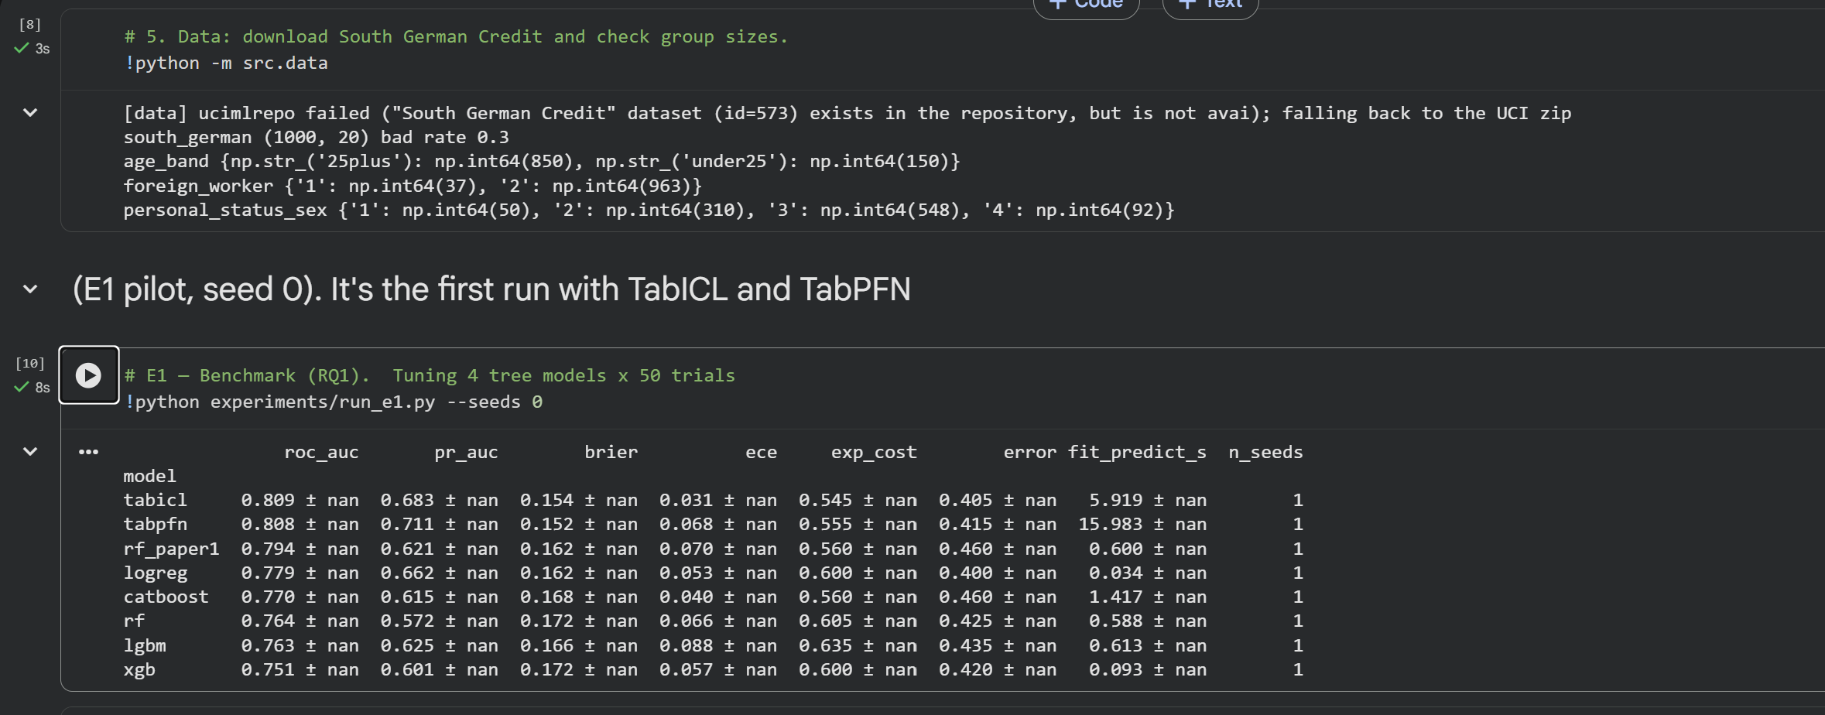
Fig. A.1. Data loading (group sizes) and the first E1 run on seed 0.
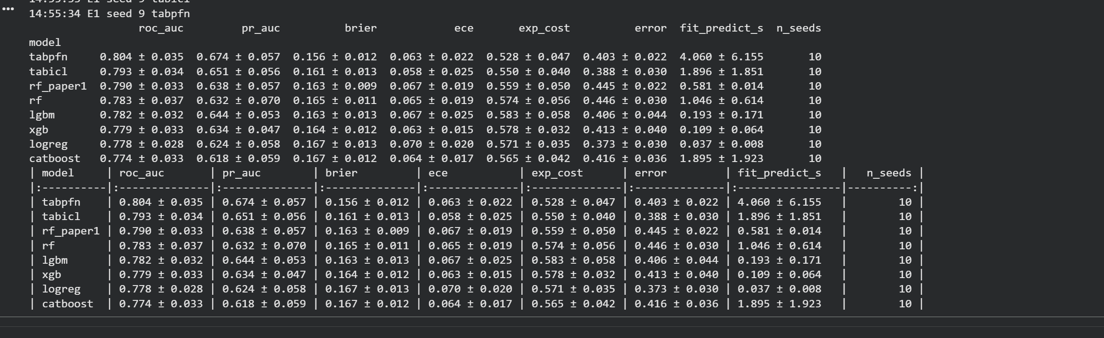
Fig. A.2. E1 benchmark summary over 10 seeds (Table II).
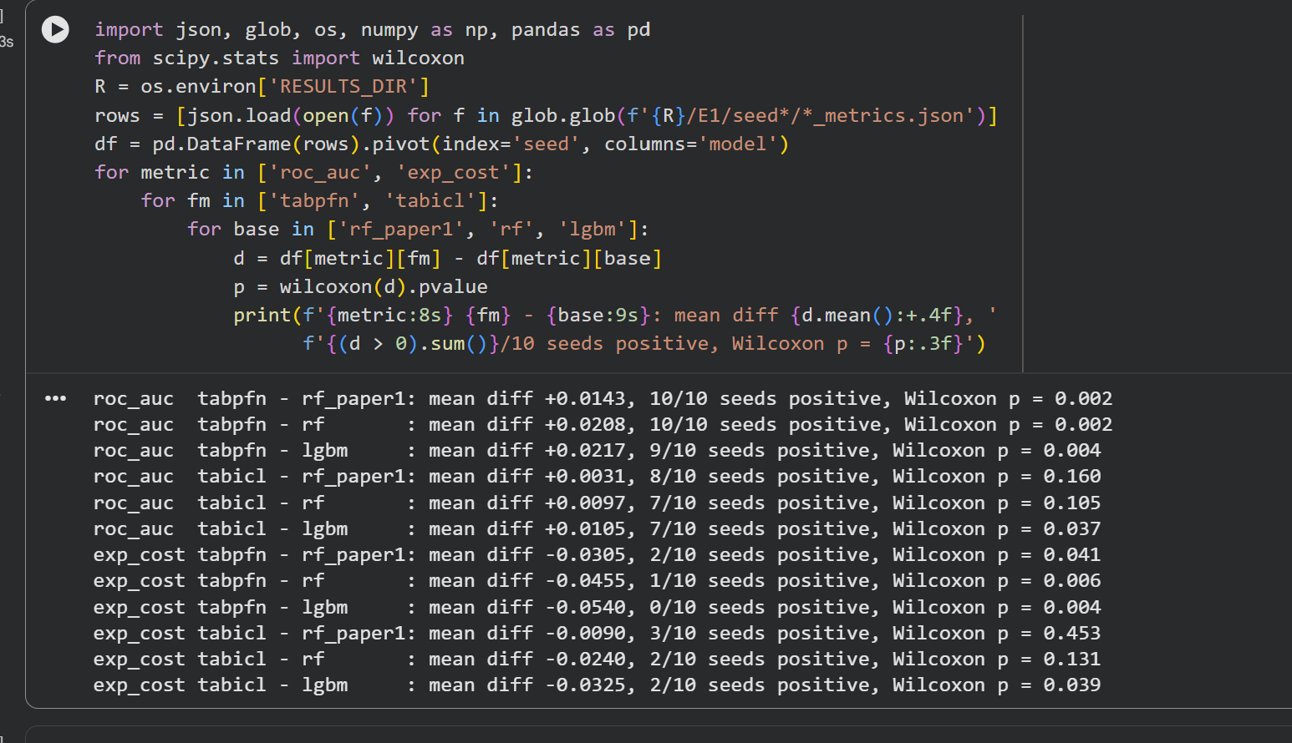
Fig. A.3. Paired Wilcoxon tests between foundation models and baselines (Table III).
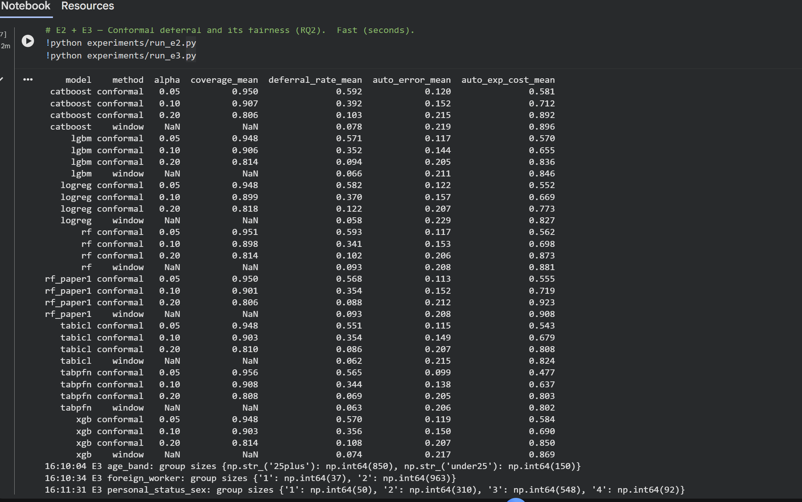
Fig. A.4. E2 conformal deferral summary for all models (Table IV).
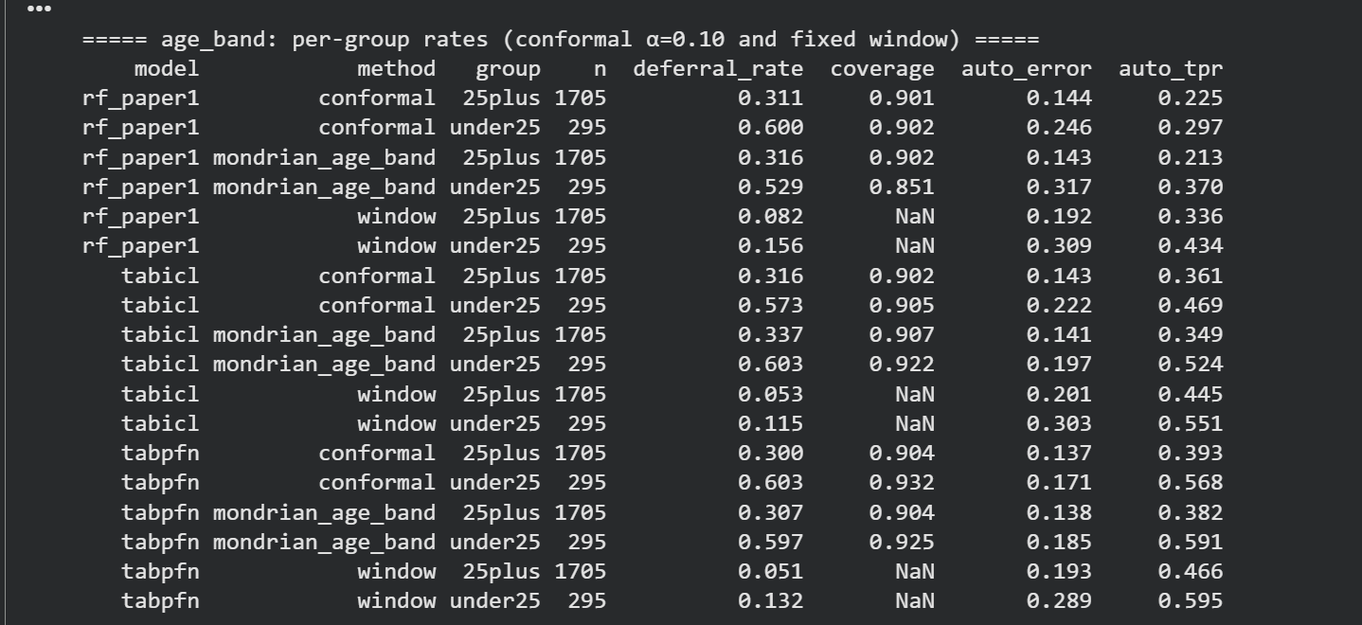
Fig. A.5. E3 deferral, coverage, error and TPR by age band.
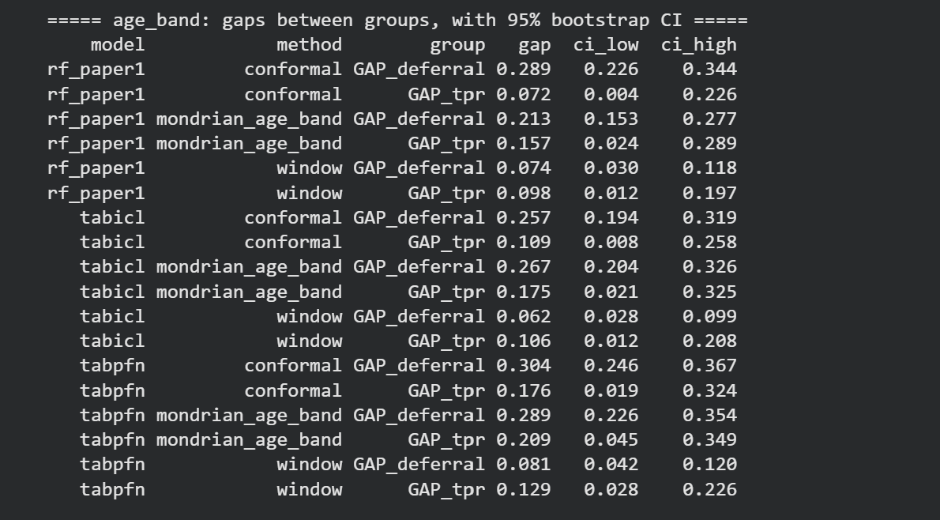
Fig. A.6. E3 age-band gaps with 95% bootstrap intervals (Table V).
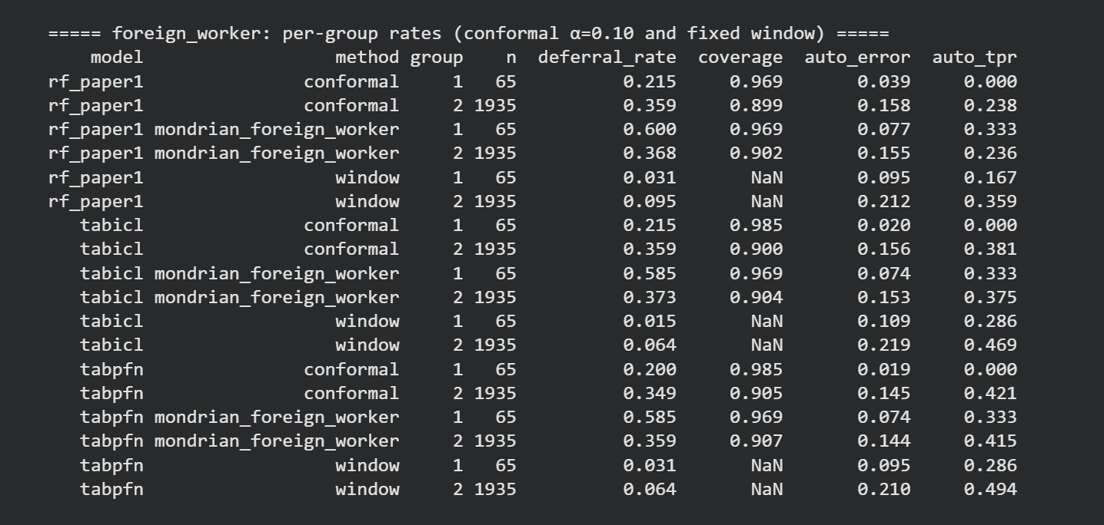
Fig. A.7. E3 results by foreign-worker status.
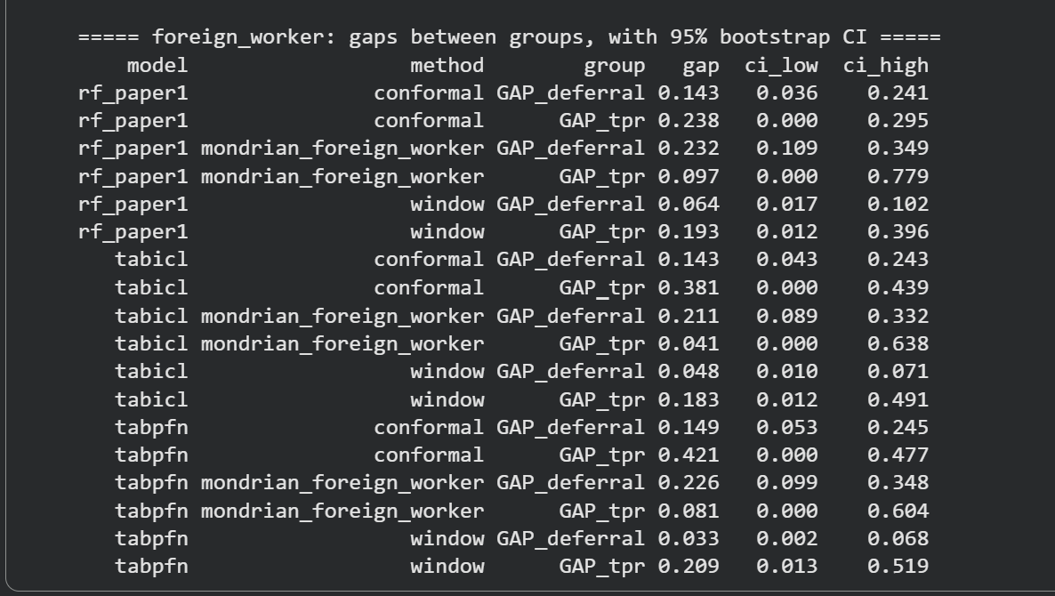
Fig. A.8. E3 foreign-worker gaps with 95% bootstrap intervals.
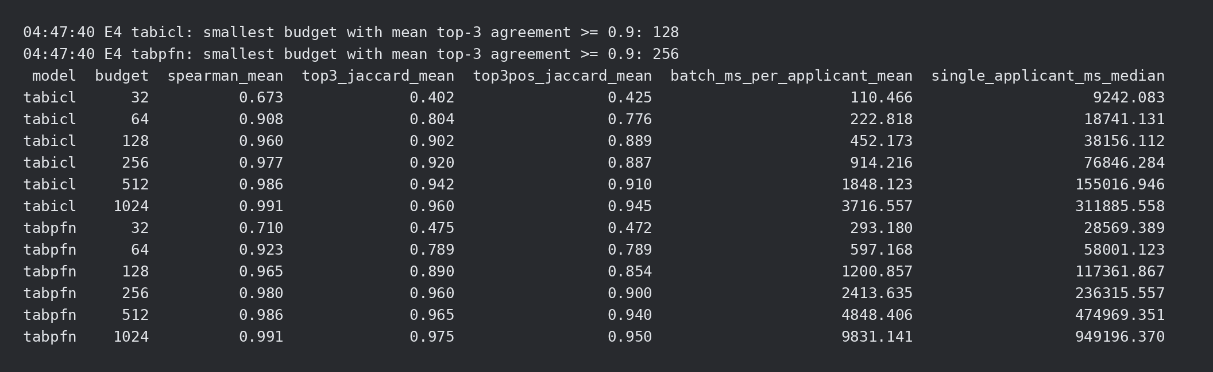
Fig. A.9. E4 explanation budget summary, split 0 (Table VI); standard-deviation columns are empty for one split and are not shown.
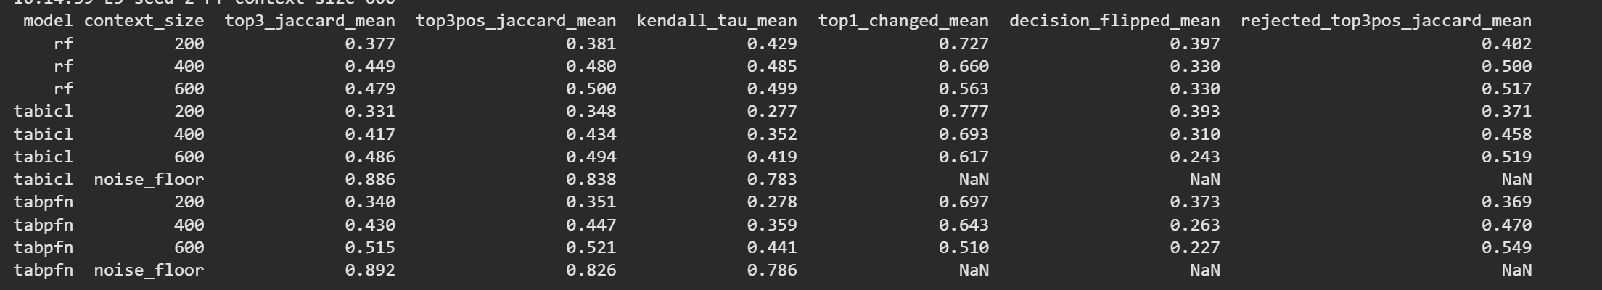
Fig. A.10. E5 stability summary, mean over splits 0–2 (Table VII).
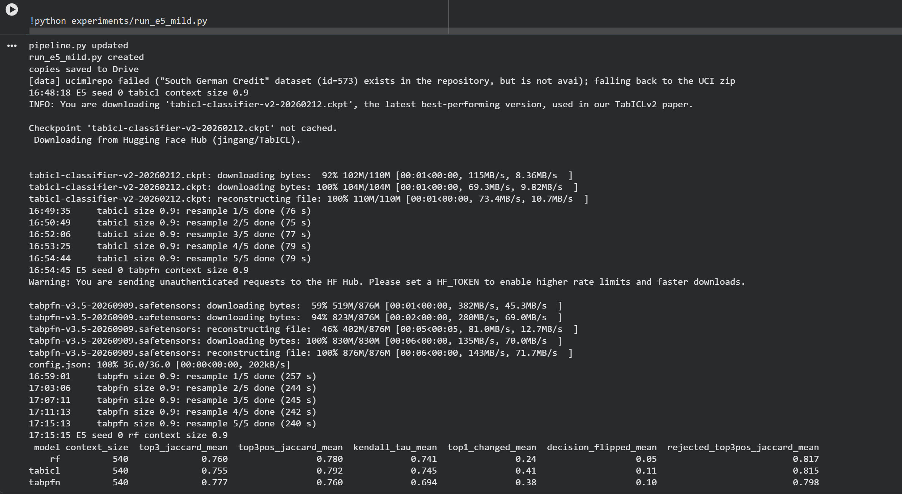
Fig. A.11. E5 milder update: each context keeps 90% of rows (540), split 0 (Table VIIa).
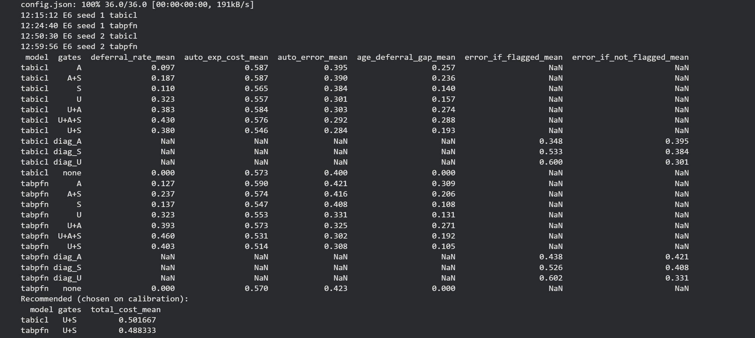
Fig. A.12. E6 gate ablation, mean over splits 0–2 (Tables IX and X). Gate rows fill the deferral and cost columns; diagnostic rows (diag_) fill only the flagged/not-flagged error columns, so the other cells are empty (NaN).

Appendix B. Verification of the Results
The following checks were made so that the results can be trusted and reproduced. Each check states what was tested and what was found.
TABLE XI. Verification checklist
Check | How it was tested | Result
Shapley code is correct | KernelSHAP with all coalitions compared with brute-force exact Shapley values on a test game (automated test) | Identical (difference 0.0)
Shapley estimate converges | Error against exact values falls as the budget grows; efficiency Σφ = v(N) − v(∅) holds | Passed
Nested budgets are exact | Explanations from one nested run compared with separate runs for each budget | Identical (difference 0.0)
Conformal code is correct | 200 simulated datasets with known probabilities; average coverage at α = 0.10 | 0.90 (target 0.90)
Coverage on real data | Empirical coverage of every model and α in E2 | Within 2 points of 1 − α for all models
Full pipeline runs | E1–E6 run end to end on synthetic data with a stand-in model before the real runs | Passed on the workspace and on Colab
No data leakage | Scaling, tuning and thresholds use the context or calibration split only; AUC well below the 0.85 leakage warning level | Max AUC 0.804; passed
No tuning on test data | α, θ, τ and the recommended gate setting chosen on calibration applicants only | Passed
Same splits for all models | Row indices saved to files for seeds 0–9 and read by every model | Passed; enables paired tests
Fair baselines | Tree models tuned with Optuna (50 trials, 3-fold CV on the context set) | Tuned models reported even where they lost
Differences are real | Wilcoxon signed-rank test on 10 paired splits; bootstrap 95% CIs for group gaps | TabPFN p ≤ 0.041; age gap CI excludes 0
Instability is not noise | Same context explained twice with different random coalitions (noise ceiling) | 0.89 vs 0.49–0.52 under resampling
Result holds under a realistic change | Milder update (90% of rows kept) as a second resampling scenario | Agreement 0.76–0.78; top-1 still changes for 24–41%
Reference is independent | E4 reference (2,048 runs) drawn independently of the tested budgets | Passed; agreement not inflated
Corrected data | South German Credit (UCI 573) used instead of Statlog; 1,000 rows, 30% bad; group sizes printed and recorded | Passed
Numbers match outputs | Every table value copied from the saved Colab outputs (Appendix A); paired win counts recounted (ties excluded) | Passed

Checks still to do before submission: confirm references [3] and [8] and the wording of the EU AI Act articles against their official sources; regenerate every table from the scripts on a fresh copy of the repository; record the exact package versions (pip freeze) in the paper.

